--Add test for new constraints default

--Test empty string domain check CHECKED
insert into Staff values (4, '');
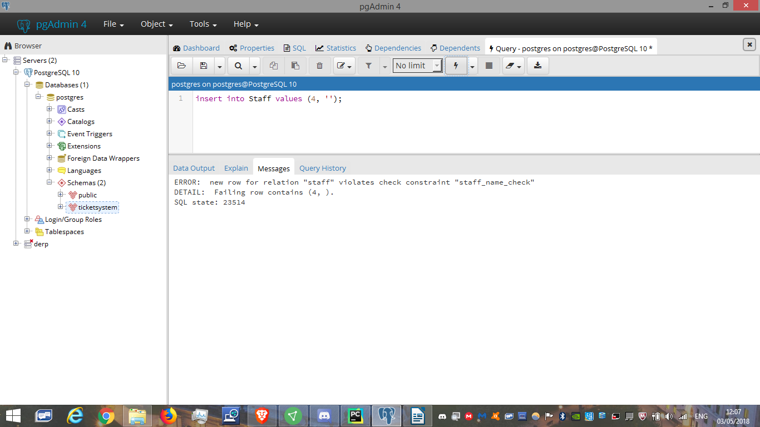
--Test Ticket default timestamp

insert into Ticket (TicketID, Problem, Status, Priority, CustomerID, ProductID) values (3, 'Example', 'open', 1, 1, 1)
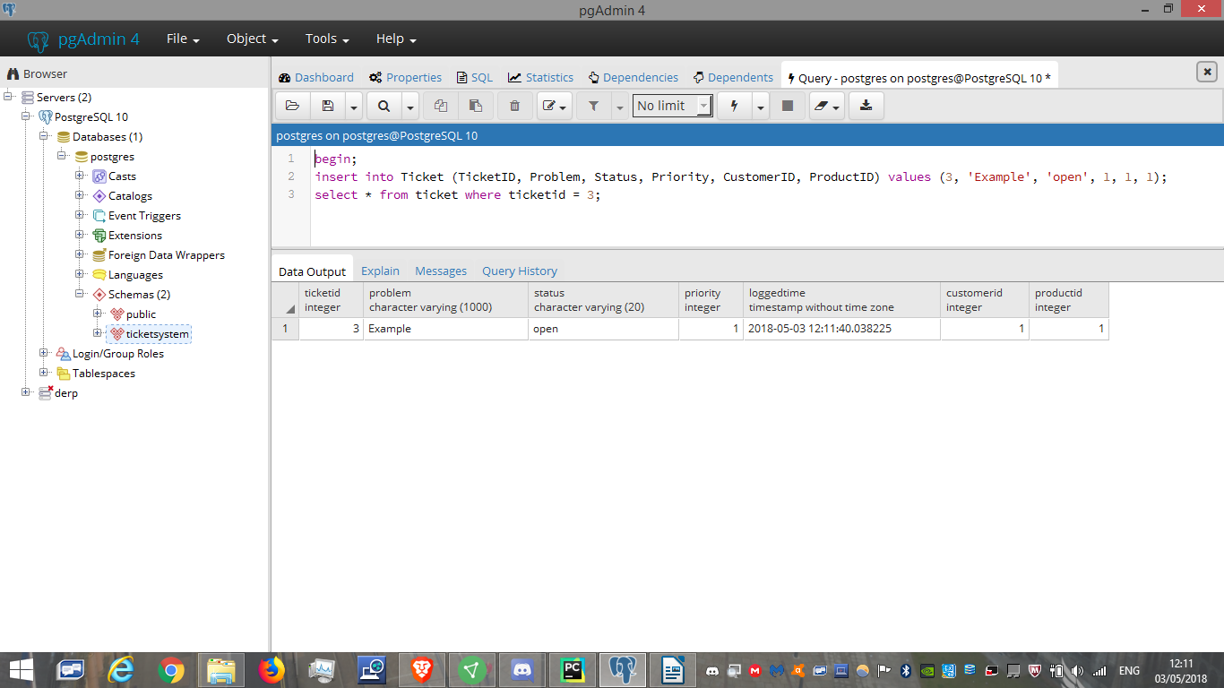

--Test Ticket Status domain constraint
--Positive CHECKED
insert into Ticket values (3, 'Example', 'open', 1, current_timestamp, 1, 1)
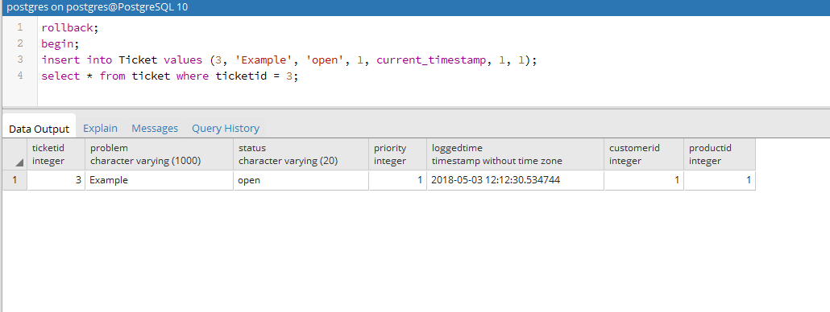

--Negative CHECKED
insert into Ticket values (3, 'Another Example', 'wacky stuff', 3, current_timestamp, 2, 2)
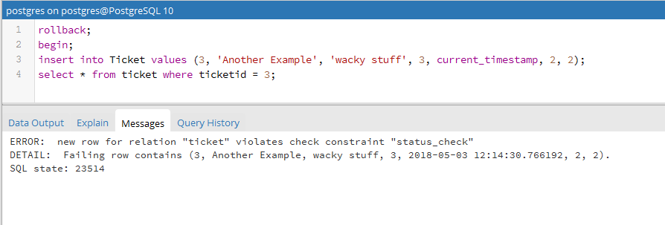

--Test that a ticket isn't allowed to be closed until it has at least one update CHECKED
insert into Ticket values (3, 'Illegal', 'closed', 1, current_timestamp, 1, 1);
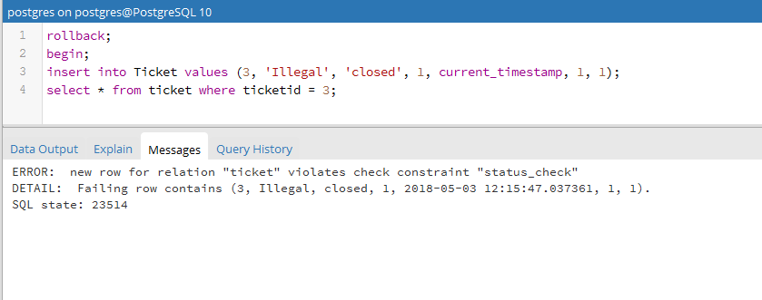
--Test Priority domain constraint

--Negative CHECKED
insert into Ticket values (3, 'Another Example more', 'open', 1070, current_timestamp, 2, 1)
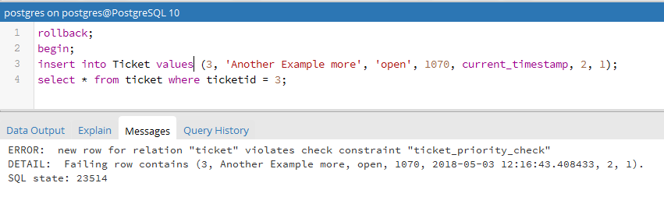
--Test Foreign key behaviour

--Test that a customer or staff with tickets ISN'T deleted CHECKED
delete from customer where CustomerID = 1;
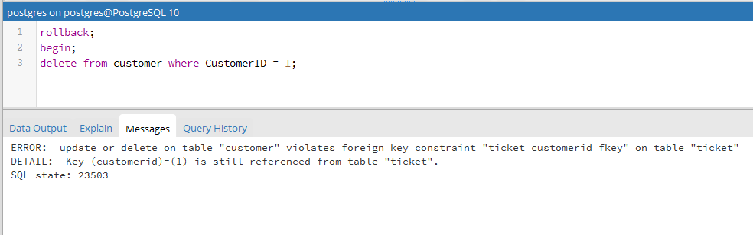
delete from staff where staffid = 1;

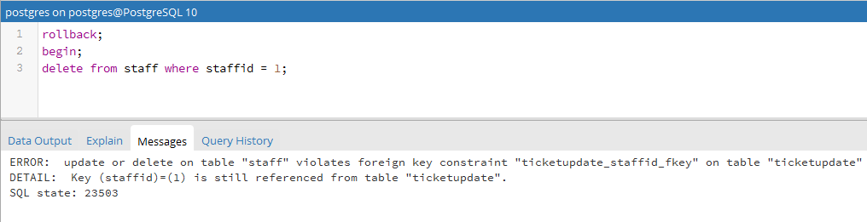

--Test converse CHECKED
insert into Customer values (4, 'Temp', 'tempest man');
delete from Customer where CustomerID = 4;
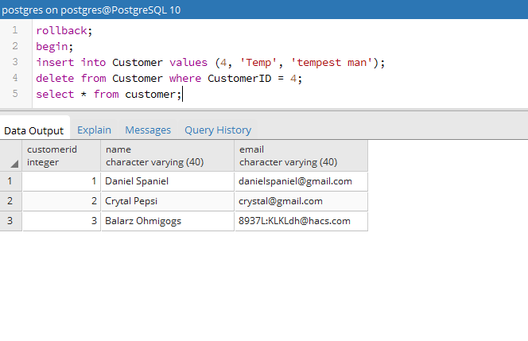
--Test that updates on an ID with tickets cascade CHECKED

update Customer set customerid = 90 where customerid = 1;
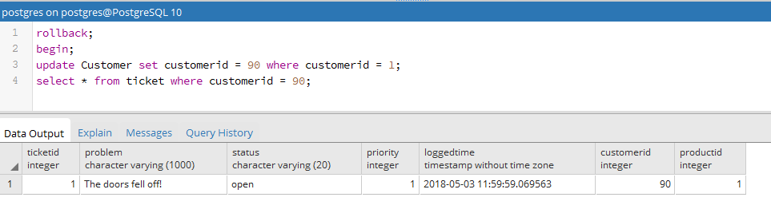

--Test that deleting a product deletes its associated tickets CHECKED
delete from product where ProductID = 1;
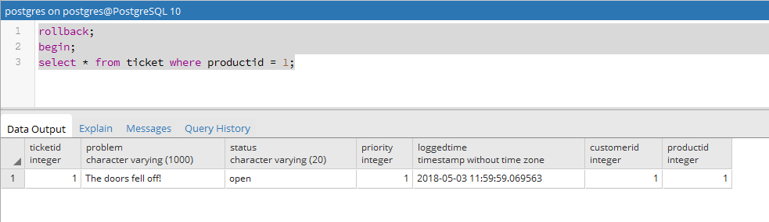
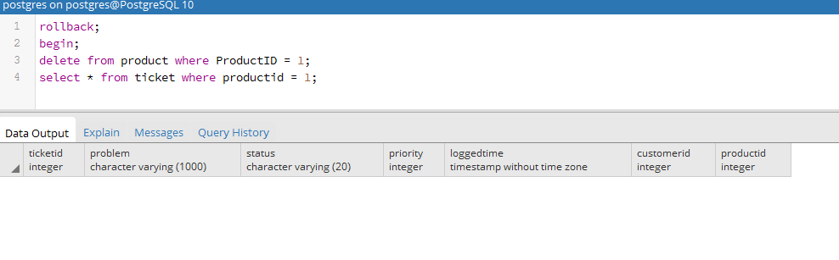
--Test that deleting a ticket deletes its associated ticketupdates CHECKED

delete from ticket where ticketid = 1;
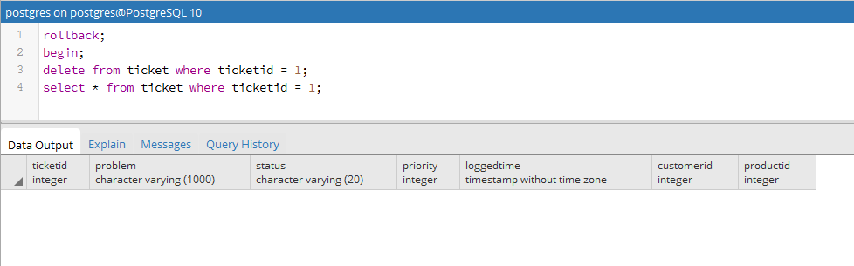
--Test email unique behaviour
--Test that no duplicate email allowed CHECKED
insert into Customer values (4, 'Temp', 'danielspaniel@gmail.com');
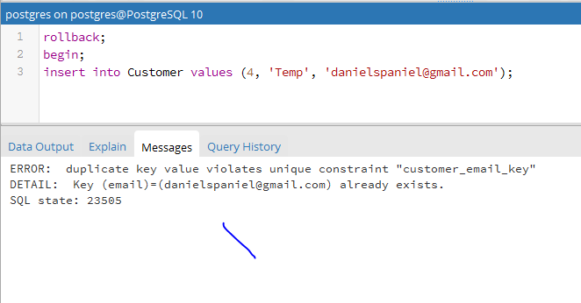
--Test primary key domain constraints
--Negative CHECKED
insert into Customer values (-5, 'Temp', 'danielspan11iel@gmail.com');
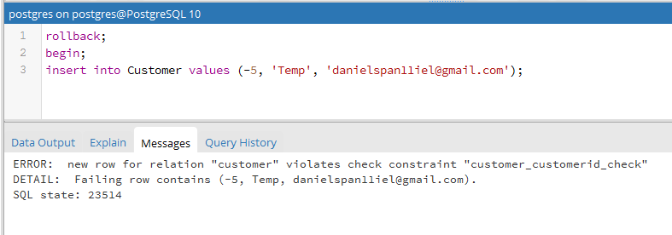
--Test tickethasupdate function
--Expecting true CHECKED
insert into Ticket values (10, 'Example', 'open', 1, current_timestamp, 1, 1);
insert into TicketUpdate values (10, 'Steveo IS a cool guy, case closed', current_timestamp, 10, 1);
select tickethasupdate(10);
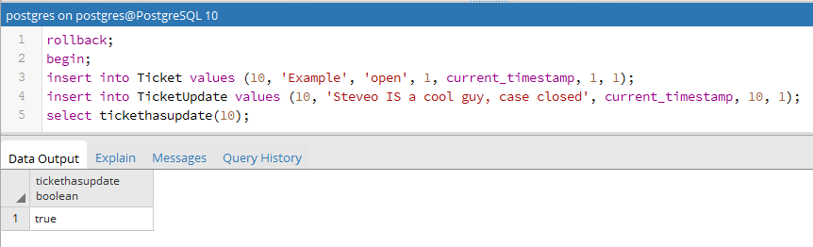
--Expecting false CHECKED
insert into Ticket values (10, 'Example', 'open', 1, current_timestamp, 1, 1);
select tickethasupdate(10);
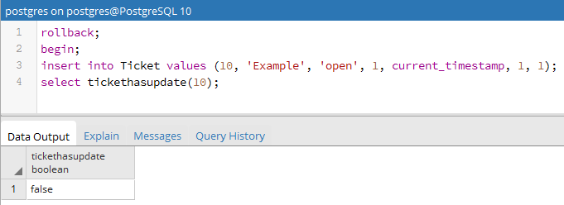

--Test openticketlatestupdate view
--Expecting ticket with ticketid = 1 with update CHECKED
select * from openticketlatestupdate;
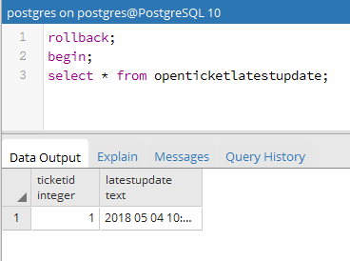
--Expecting ticket with ticketid = 1 with no update CHECKED
delete from ticketupdate where ticketid = 1;
select * from openticketlatestupdate;
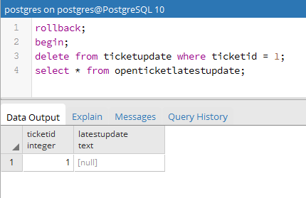

--Test ticketandupdates
--Expecting 2 rows CHECKED
select * from ticketandupdates(2);
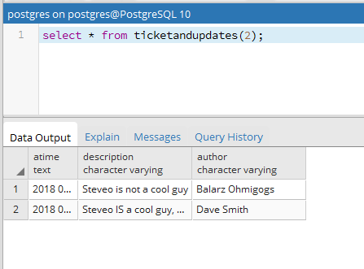

--Expecting only the original ticket CHECKED
INSERT INTO Ticket VALUES(3, 'Houston we have a problem', 'open', 3, current_timestamp, 1, 1);
select * from ticketandupdates(3);
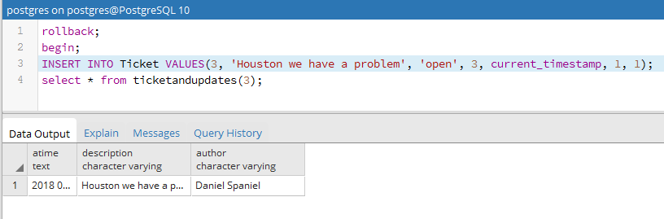
--Test closedticketupdatestatus
--Expecting 1 row
select * from closedticketupdatestatus;
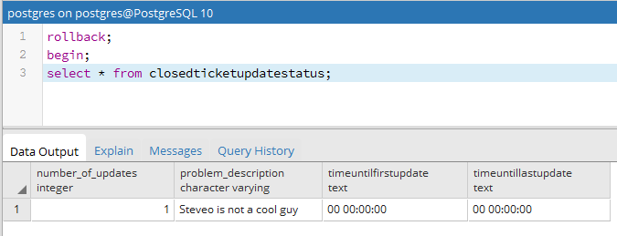
--Expecting 2 rows
insert into ticketupdate values (3, 'Steveo IS a cool guy, case closed', current_timestamp, 1, 1);
update ticket set status = 'closed' where ticketid = 1;
select * from closedticketupdatestatus;
